Team Project

Team Members:

1. Sabaa Fatani 21222904 (Core Developer/Team Leader)
2. Akber Ali 21262449 (Project Manager)
3. Abdul Ahmed 21324741
4. David
5. Subodh

Contents

Introduction 2

Planning and Implementation 3

Spider Diagram 3

Research 3

First Design 3

Draft Design 4

Database Structure 4

Database Relation 8

Features 8

Code 9

Draft Html Version 9

Conclusion 14

Bibliography 15

Appendix 16

# Introduction

Softwares:

* Photoshop
* Notepad++
* HeidiSQL

Programming Languages:

* HTML
* PHP
* CSS
* MySQL

Project Scenario

Supermarket A supermarket requires an information system to automate its management of products and customers. A customer purchases products by filling a basket and taking the goods to a till or by going on-line. On-line customers must register with the supermarket first before they can purchase goods, otherwise you can assume that filling an e-basket and paying is the same as being physically in-store. When the goods are paid for the supermarket registers that the stock on the shelves has been reduced and will automatically place an order with the supplier if the amount of goods fall below a given threshold. After processing the goods at the till (or on-line) the customer must pay. They enter their payment details and the supermarket connects to a bank in order to make the transaction. The transaction may be declined if the customer does not have sufficient funds.

The supermarket operates a loyalty scheme where customers earn points as they buy goods. The points are awarded based on the overall amount spent in each visit. Occasionally there may be a special deal on selected items where they earn extra points (for example a given brand of soap might earn an extra 100 points). The loyalty scheme is provided by a separate company and the customer must register with the company in order to get a loyalty card which contains the identifier of their loyalty account. Loyalty points are earned and then burned (transformed into money) against purchases with the supermarket. The translation between points and money is managed by the loyalty scheme company and occurs as a bank transaction initiated by the customer when they purchase goods. The supermarket runs special offers on certain goods from time to time. For example, 3 for 2 deals on apples. The deals operate for a fixed time and must be taken into account when the customer buys the goods. The deals are: 3-for-2; half-price; buy-1-get-1-free; earn 100 extra loyalty points. The marketing department in the supermarket keeps track of the products bought by each customer and the overall amount spent in each transaction. This information is used to work out who to target with mail shots when special offers are made available

# Planning and Implementation

## Spider Diagram

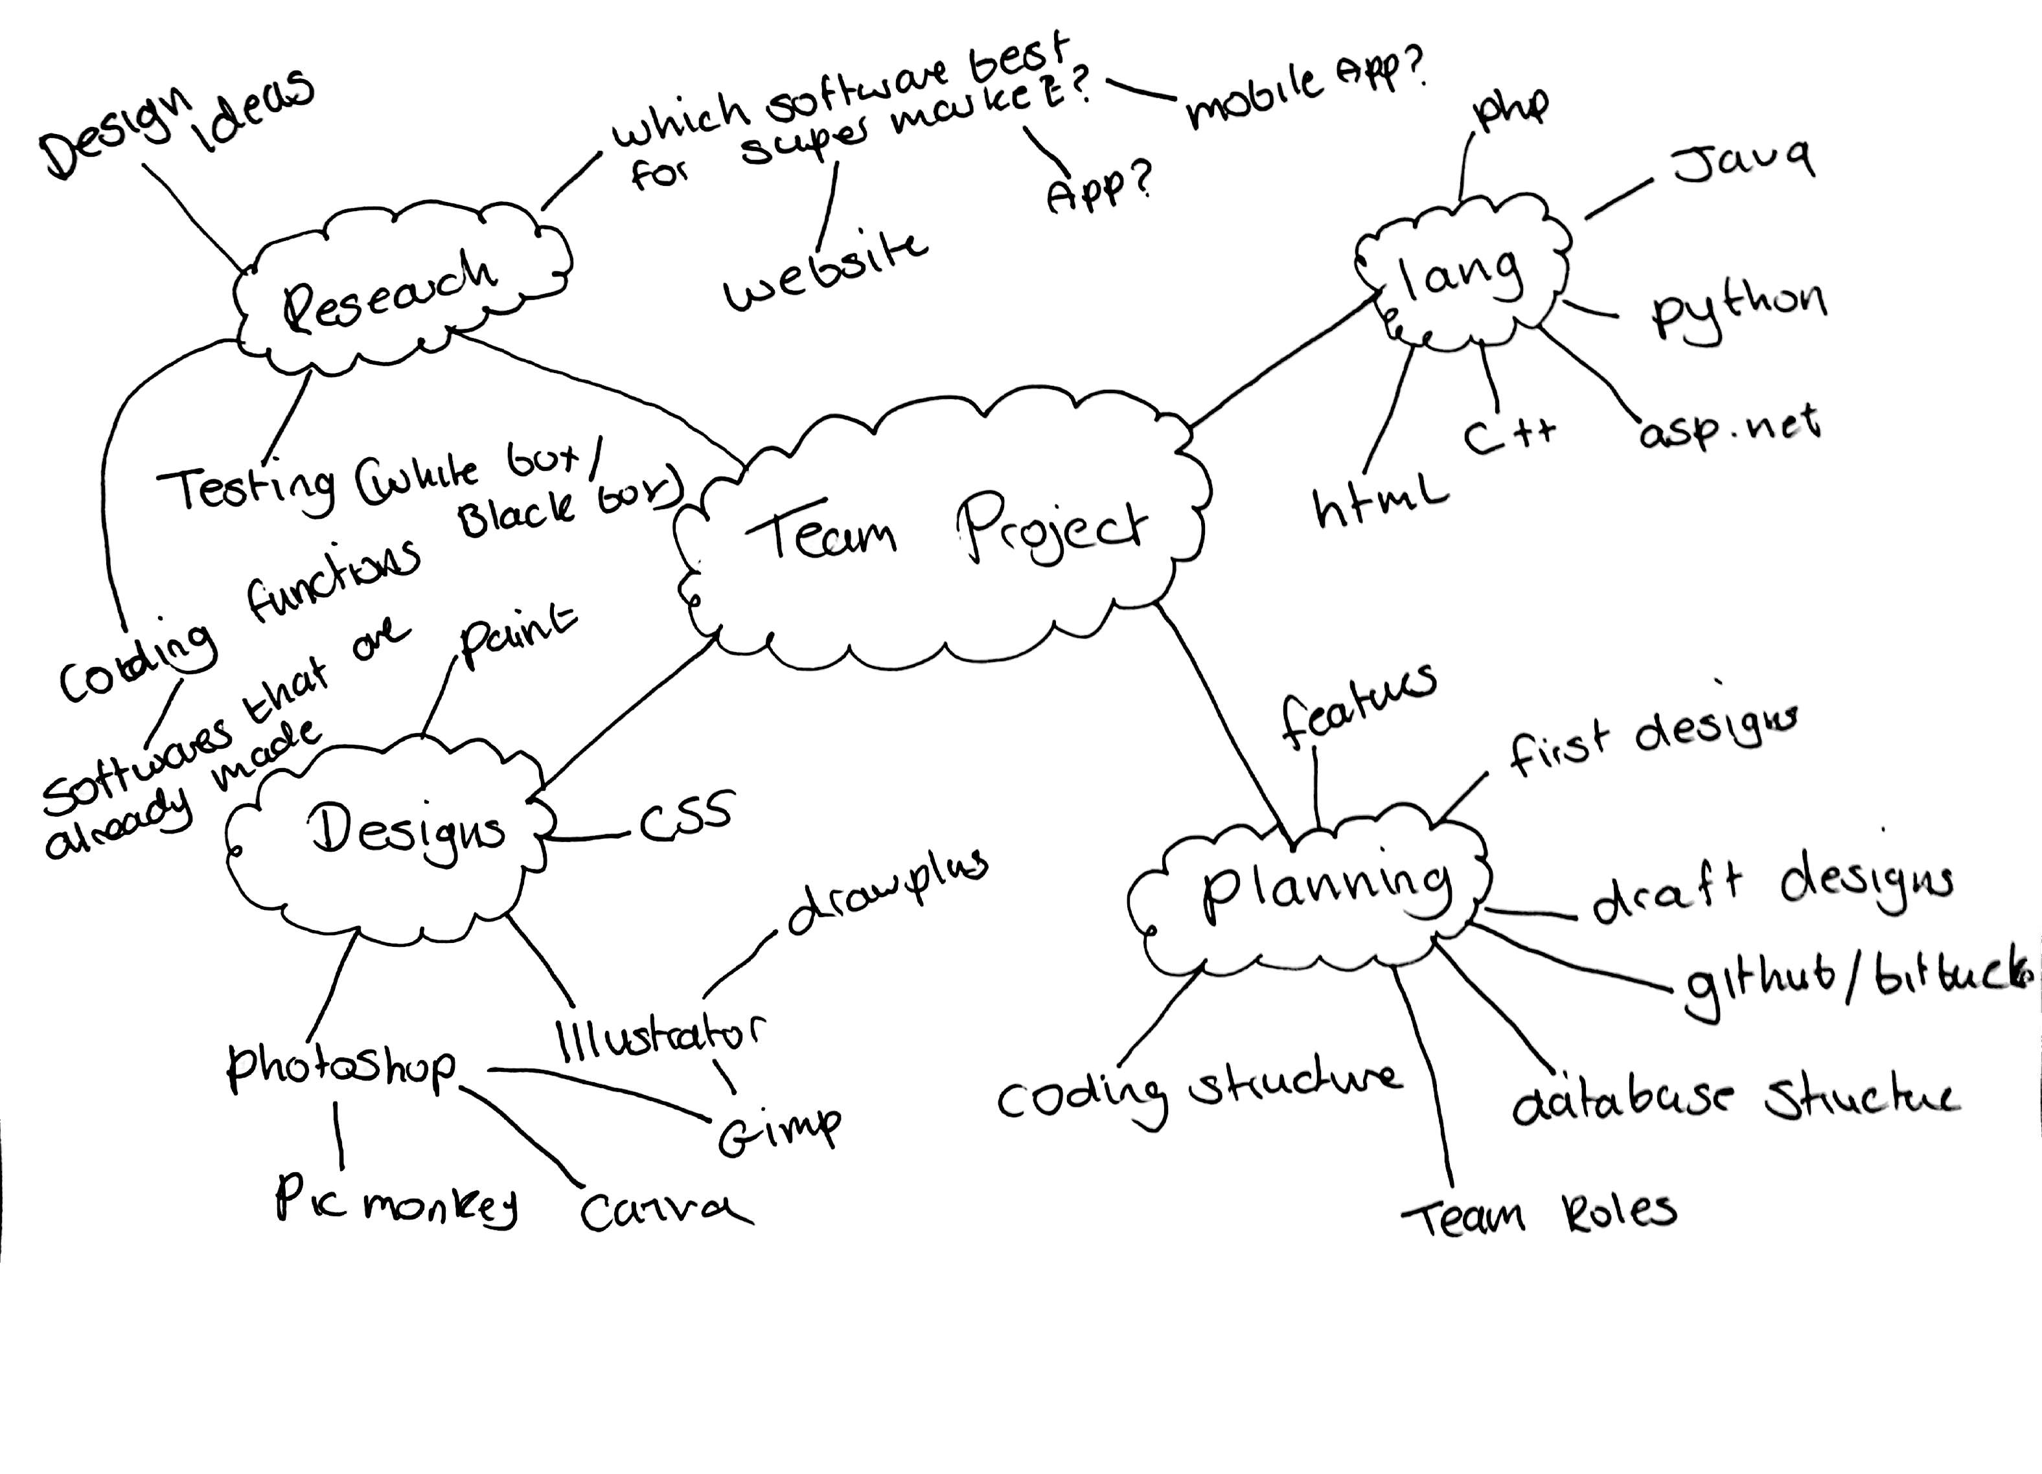

## Research

## First Design

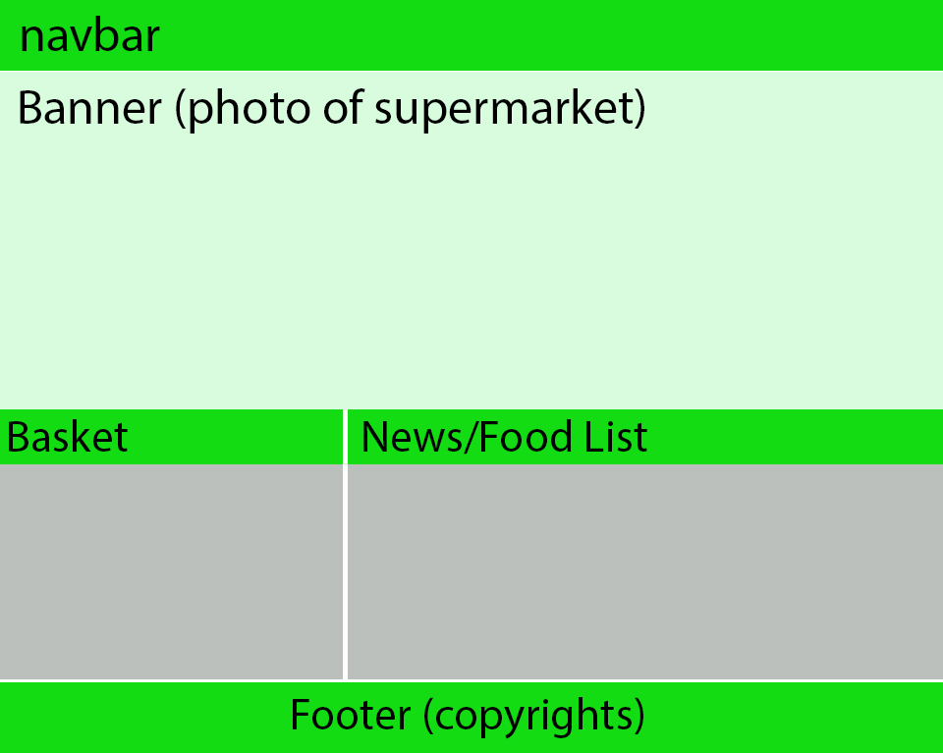

## Draft Design

## Database Structure

Database name = MarketCMS

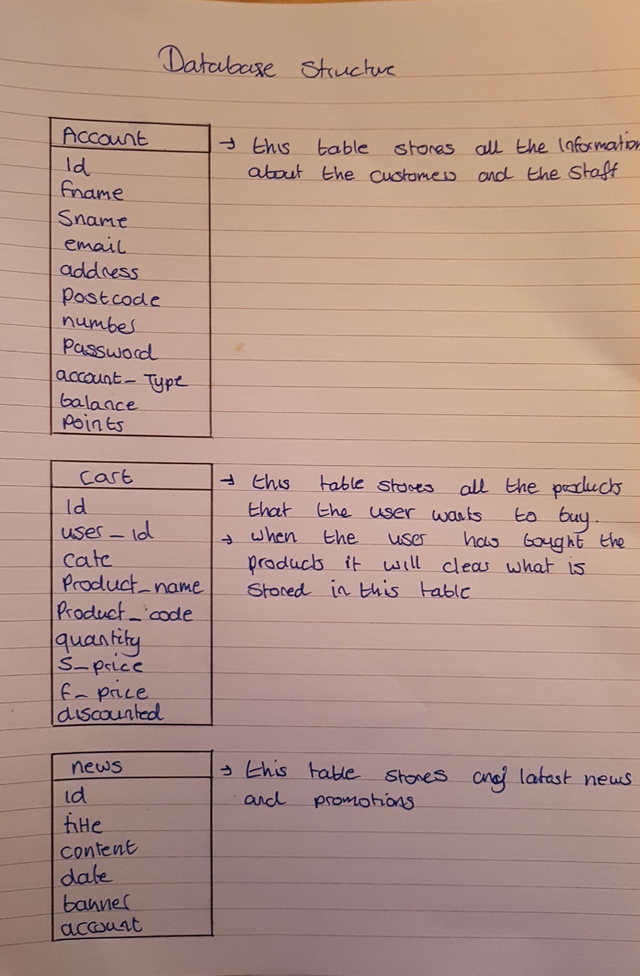

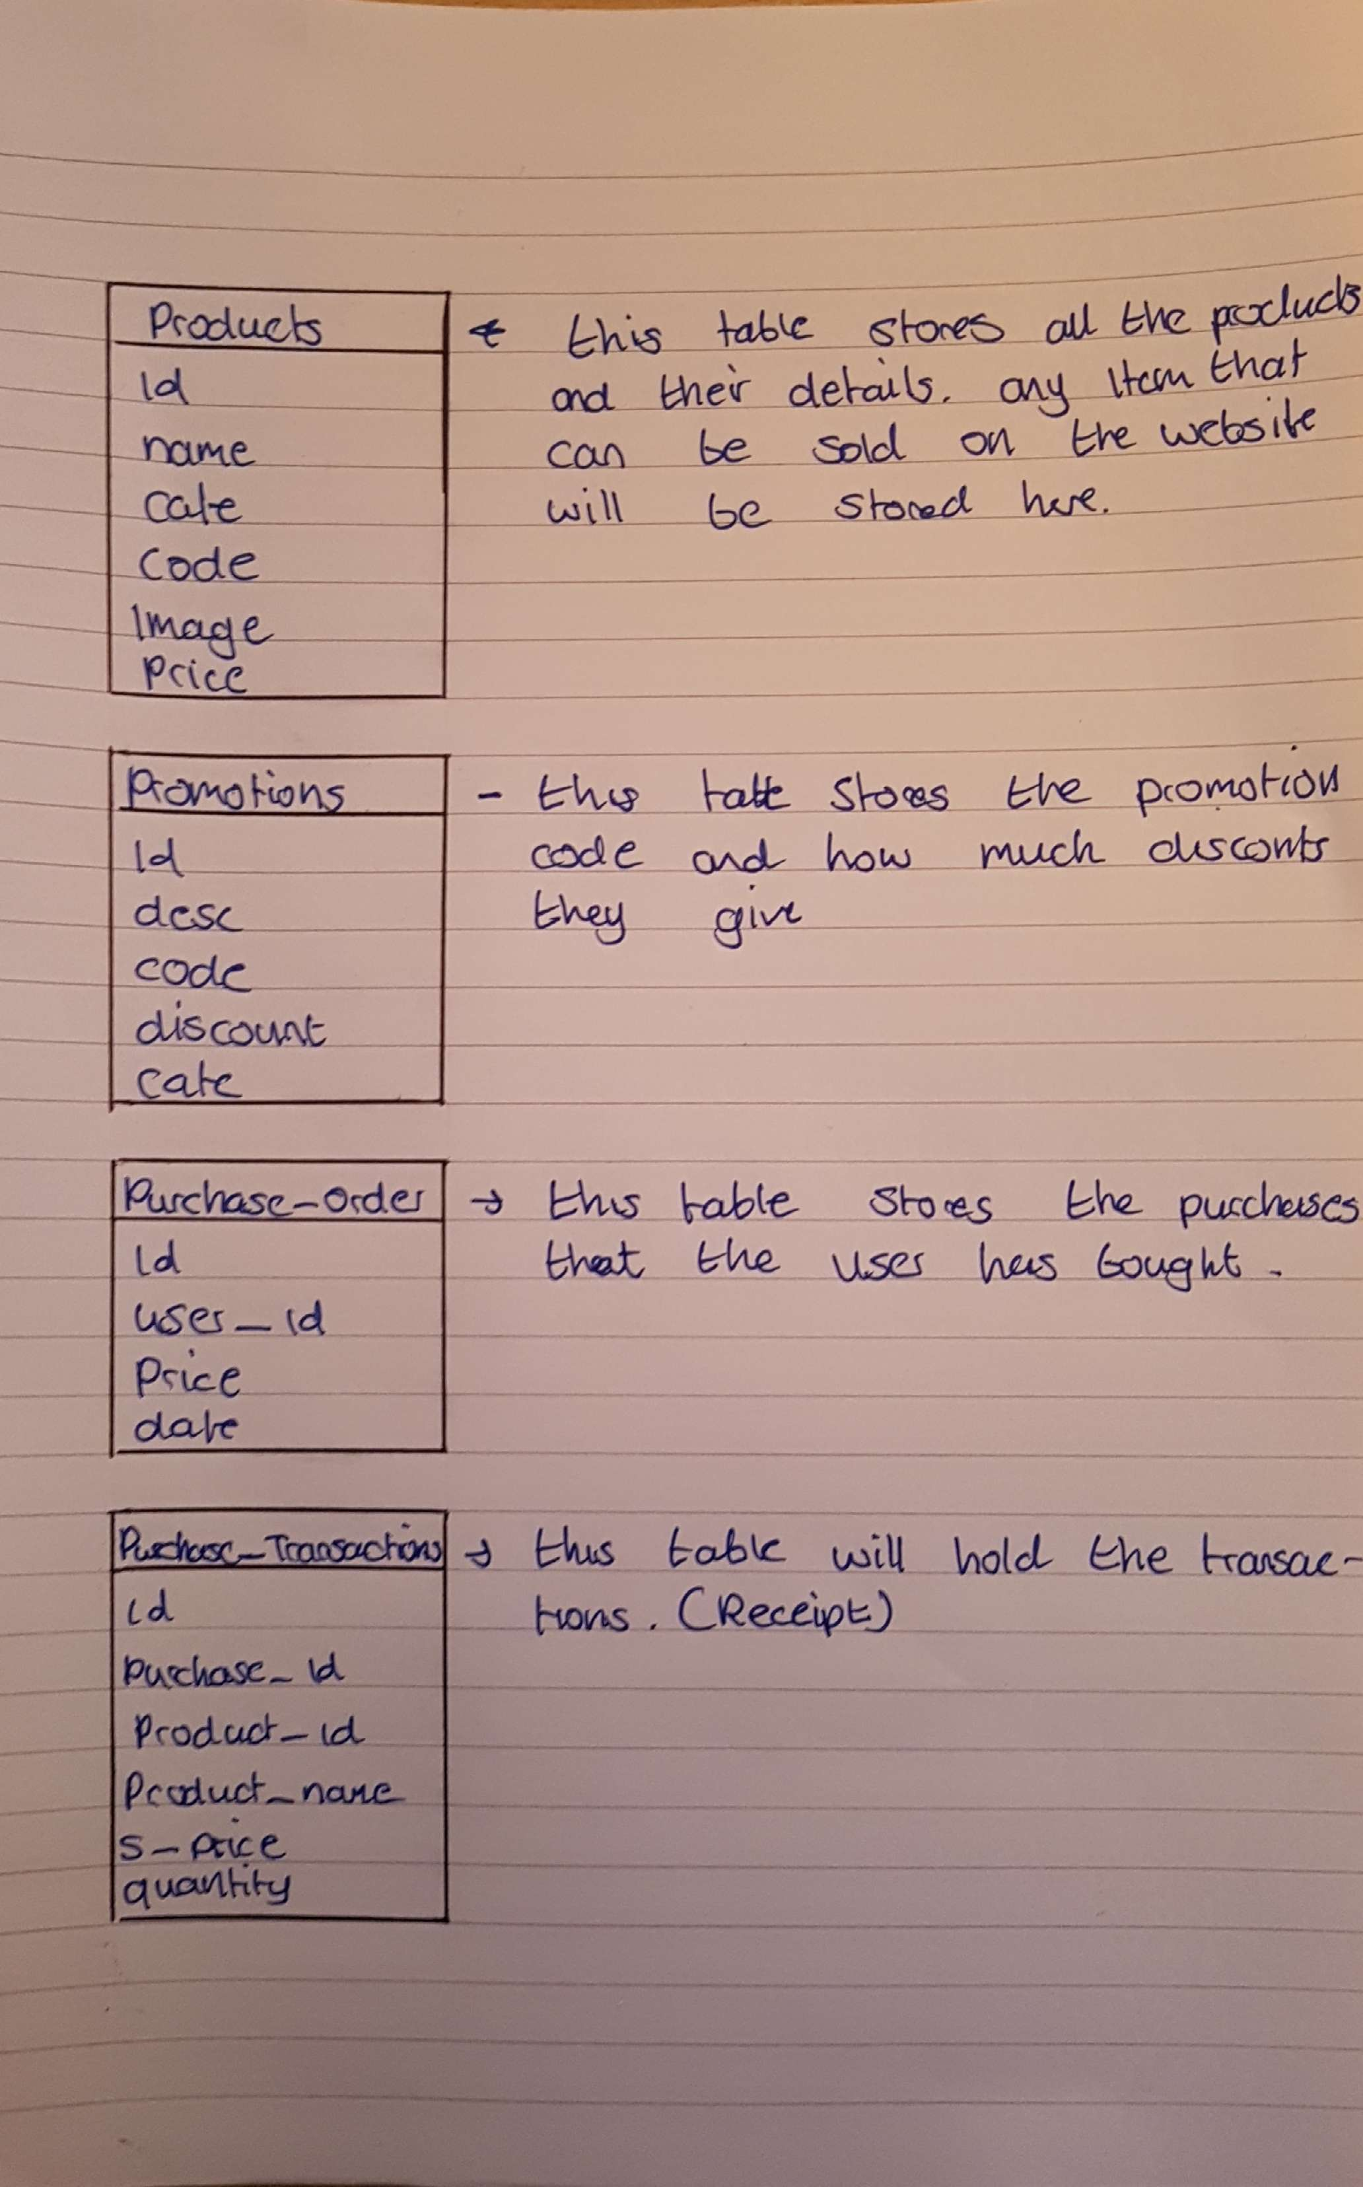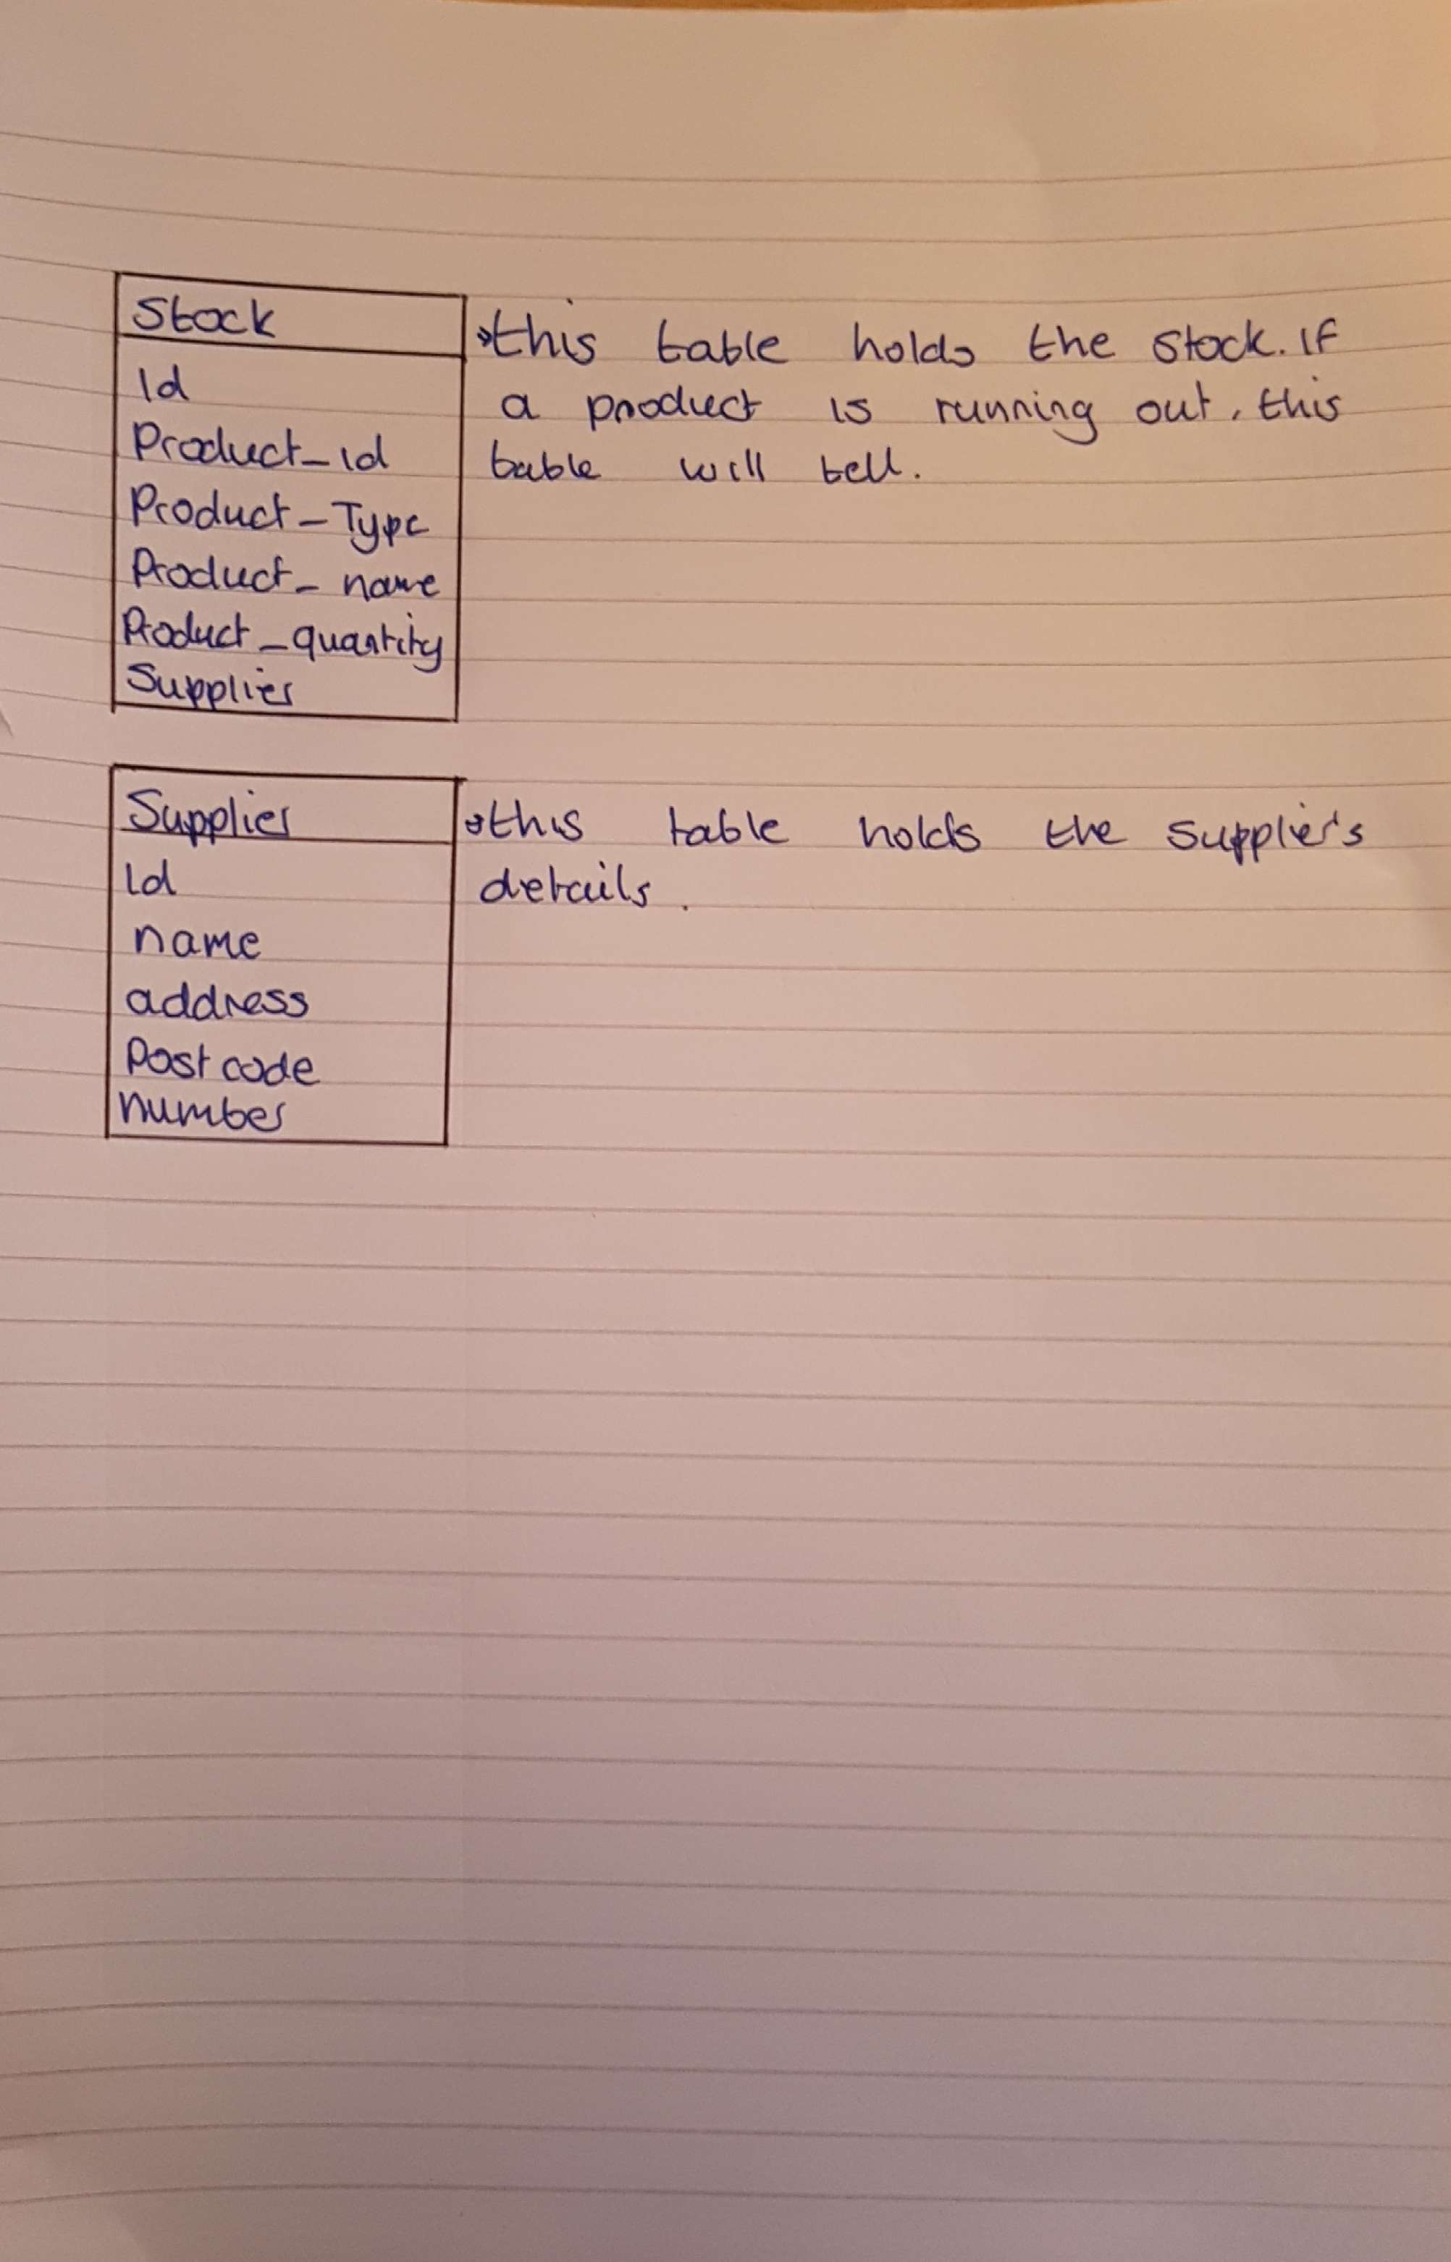

## Database Relation

## Features

# Code

## Draft Html Version

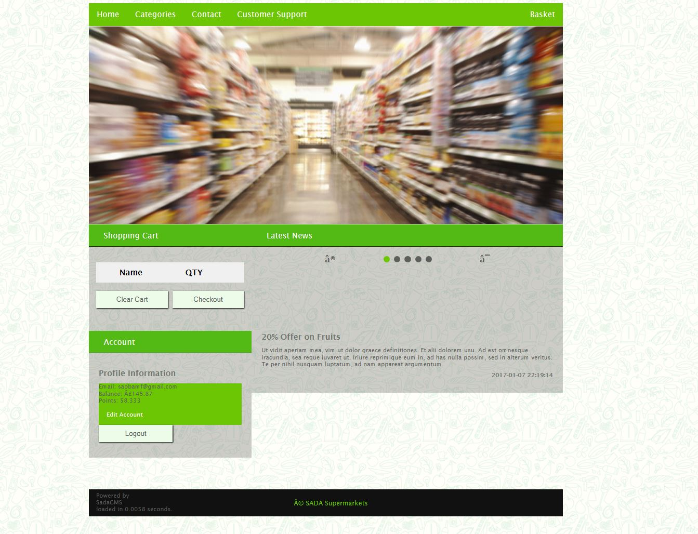

<html>

<head>

<meta name=**"viewport"** content=**"width=device-width, initial-scale=1.0"**>

<link rel=**"stylesheet"** href=**"style/draft_style.css"**>

<script src=**"js/js-image-slider.js"** type=**"text/javascript"**></script>

<title>**Sada Supermarket**</title>

</head>

<!-- Where the Content goes -->

<body>

<!-- Document Header Starts -->

<div class=**"wrapper"**><!-- Wraps the Document to a size -->

<div class=**"navbar"**><!-- This is where the Navbar starts -->

<!-- List of linked buttons that are placed in the navbar-->

<ul>

<li><a class=**"active"** href=**"index.php"**>**Home**</a></li>

<li class=**"dropdown"**>

<a href=**"javascript:void(0)"** class=**"dropbtn"**>**Categories**</a>

<div class=**"dropdown-content"**>

<a href=**"?cat=1"**>**Fruits**</a>

<a href=**"?cat=2"**>**Veg**</a>

<a href=**"?cat=3"**>**Meat and Poultry**</a>

<a href=**"?cat=4"**>**Fish and Seafood**</a>

<a href=**"?cat=5"**>**Bakery**</a>

<a href=**"?cat=6"**>**Drinks**</a>

<a href=**"?cat=7"**>**Electronics**</a>

<a href=**"?cat=8"**>**Kids Toys**</a>

<a href=**"?cat=9"**>**Bed, Bath and Home**</a>

</div>

</li><li><a href=**"?page=contact"**>**Contact**</a></li><li><a href=**"?page=htc"**>**Customer Support**</a></li>

<li style=**"float:right"**><a href=**"#about"**>**Basket**</a></li>

</ul>

</div>

<!-- Displays the header(image banner) -->

<div class=**"header"**></div>

<div class=**"row"** style=**"margin-top:1px;"**>

<!-- Left col content starts here -->

<div class=**"leftcol"**>

<div class=**"leftPanelTitle"**>**Shopping Cart**</div><!-- Title bar for Left Col -->

<div class=**"leftPanelContent"**><!-- Content for Left Panel starts here -->

<!-- Shopping Cart Starts here -->

<div id=**"shopping-cart"**><form method=**"post"** action=**""**>

<br><table cellpadding=**"10"** cellspacing=**"1"**>

<tbody>

<tr>

<th><strong>**Name**</strong></th>

<th><strong>**QTY**</strong></th>

<th><strong></strong></th>

</tr>

<tr>

</tr>

</tbody>

</table>

<br>

<!-- Buttons that are used to Clear or go to Checkout -->

<button name=**"clear"** type=**"submit"** value=**""** style=**"width: 145px;"**>**Clear Cart**</button>

<button name=**"checkout"** type=**"submit"** value=**""** style=**"width: 145px; float:right;"**>**Checkout**</button>

</form>

<br>

</div></div>

<!-- Next Left Box starts here -->

<div class=**"leftPanelTitle"**>**Account**</div><!-- Left Title bar for Account-->

<div class=**"leftPanelContent"**><!-- Left Content for Account starts here-->

<div class=**"text"**><h1> **Profile Information** </h1><ul style=**"list-style-type:none"**>

<li> **Email: sabbamf@gmail.com**</li>

<br><li> **Balance: £145.87**</li>

<br><li> **Points: 58.333**</li>

</ul><ul style=**"list-style-type:none;"**>

<li><a href=**"?ucp=1"**> **Edit Account**</a></li>

</ul><form action=**"/core/logout.php"** method=**"post"**>

<button type=**"submit"** name=**"logout"**>**Logout**</button>

</form>

</div>

</div></div>

<!-- Where the Right col starts -->

<div class=**"rightcol"**>

<div class=**"rightPanelTitle"**>**Latest News**</div><!-- Right Panel Title-->

<div class=**"rightPanelContent"**><div style=**"text-align:center"**>

<!-- Where the Slider starts, -->

<a class=**"prev"** onclick=**"plusSlides(-1)"**>**❮**</a>

<span class=**"dot active"** onclick=**"currentSlide(1)"**></span>

<!-- Different Slides starts here -->

<span class=**"dot"** onclick=**"currentSlide(2)"**></span>

<span class=**"dot"** onclick=**"currentSlide(3)"**></span>

<span class=**"dot"** onclick=**"currentSlide(4)"**></span>

<span class=**"dot"** onclick=**"currentSlide(5)"**></span>

<a class=**"next"** onclick=**"plusSlides(1)"**>**❯**</a>

<!-- The content for the slides starts here -->

<br><br></div><div class=**"mySlides fade"** style=**"display: block;"**>

<div class=**"topic_banner"** style=**"background-image:url('/images/topic_banner.jpg')"**></div>

<div class=**"text"**><h1> **20% Offer on Fruits** </h1> **Ut vidit aperiam mea, vim ut dolor graece definitiones. Et alii dolorem usu. Ad est omnesque iracundia, sea reque iuvaret ut. Iriure reprimique eum in, ad has nulla possim, sed in alterum veritus. Te per nihil nusquam luptatum, ad nam appareat argumentum.** <h1 style=**"text-align:right; font-size:12px;"**>**2017-01-07 22:19:14** </h1></div>

</div><div class=**"mySlides fade"** style=**"display: none;"**>

<div class=**"topic_banner"** style=**"background-image:url('/images/topic_banner.jpg')"**></div>

<div class=**"text"**><h1> **20% Offer on Fruits** </h1> **Ut vidit aperiam mea, vim ut dolor graece definitiones. Et alii dolorem usu. Ad est omnesque iracundia, sea reque iuvaret ut. Iriure reprimique eum in, ad has nulla possim, sed in alterum veritus. Te per nihil nusquam luptatum, ad nam appareat argumentum.** <h1 style=**"text-align:right; font-size:12px;"**>**2017-01-08 19:31:18** </h1></div>

</div><div class=**"mySlides fade"** style=**"display: none;"**>

<div class=**"topic_banner"** style=**"background-image:url('/images/topic_banner.jpg')"**></div>

<div class=**"text"**><h1> **Lorem Ipsum** </h1> **Ut vidit aperiam mea, vim ut dolor graece definitiones. Et alii dolorem usu. Ad est omnesque iracundia, sea reque iuvaret ut. Iriure reprimique eum in, ad has nulla possim, sed in alterum veritus. Te per nihil nusquam luptatum, ad nam appareat argumentum.** <h1 style=**"text-align:right; font-size:12px;"**>**2017-01-19 00:02:44** </h1></div>

</div><div class=**"mySlides fade"** style=**"display: none;"**>

<div class=**"topic_banner"** style=**"background-image:url('/images/topic_banner.jpg')"**></div>

<div class=**"text"**><h1> **Lorem Ipsum** </h1> **Ut vidit aperiam mea, vim ut dolor graece definitiones. Et alii dolorem usu. Ad est omnesque iracundia, sea reque iuvaret ut. Iriure reprimique eum in, ad has nulla possim, sed in alterum veritus. Te per nihil nusquam luptatum, ad nam appareat argumentum.** <h1 style=**"text-align:right; font-size:12px;"**>**2017-01-19 00:02:44** </h1></div>

</div><div class=**"mySlides fade"** style=**"display: none;"**>

<div class=**"topic_banner"** style=**"background-image:url('/images/topic_banner.jpg')"**></div>

<div class=**"text"**><h1> **Lorem Ipsum** </h1> **Ut vidit aperiam mea, vim ut dolor graece definitiones. Et alii dolorem usu. Ad est omnesque iracundia, sea reque iuvaret ut. Iriure reprimique eum in, ad has nulla possim, sed in alterum veritus. Te per nihil nusquam luptatum, ad nam appareat argumentum.** <h1 style=**"text-align:right; font-size:12px;"**>**2017-01-19 00:02:44** </h1></div>

</div></div></div></div>

<br>

<br>

<!-- Footer starts here -->

<div class=**"footer"**>

<div class=**"text"** style=**"margin-left:10px;"**>**Powered by** <br>**SadaCMS**<br>**loaded in 0.0058 seconds.**<p> **© SADA Supermarkets**</p>

</div>

</div>

<!-- java scripts starts here.] -->

<script>

***var*** slideIndex **=** 1**;**

showSlides**(**slideIndex**);**

***function*** plusSlides**(**n**)** **{**

showSlides**(**slideIndex **+=** n**);**

**}**

***function*** currentSlide**(**n**)** **{**

showSlides**(**slideIndex **=** n**);**

**}**

***function*** showSlides**(**n**)** **{**

***var*** i**;**

***var*** slides **=** document.getElementsByClassName**(**"mySlides"**);**

***var*** dots **=** document.getElementsByClassName**(**"dot"**);**

***if*** **(**n **>** slides.length**)** **{**slideIndex **=** 1**}**

***if*** **(**n **<** 1**)** **{**slideIndex **=** slides.length**}**

***for*** **(**i **=** 0**;** i **<** slides.length**;** i**++)** **{**

slides**[**i**].**style.display **=** "none"**;**

**}**

***for*** **(**i **=** 0**;** i **<** dots.length**;** i**++)** **{**

dots**[**i**].**className **=** dots**[**i**].**className.replace**(**" active"**,** ""**);**

**}**

slides**[**slideIndex**-**1**].**style.display **=** "block"**;**

dots**[**slideIndex**-**1**].**className **+=** " active"**;**

**}**

***function*** openNav**()** **{**

document.getElementById**(**"mySidenav"**).**style.width **=** "250px"**;**

document.getElementById**(**"main"**).**style.marginLeft **=** "250px"**;**

**}**

***function*** closeNav**()** **{**

document.getElementById**(**"mySidenav"**).**style.width **=** "0"**;**

document.getElementById**(**"main"**).**style.marginLeft**=** "0"**;**

**}**

</script>

</div></body></html>

# Conclusion

# Bibliography

# Appendix